1. INTRODUCTION
   1. Overview

Basic details such as your name,contact details

,logo,and a job title or short description of what

You do.

* 1. Purpose

The purpose of business cards is to creat an aware

Ness of what you do to your prospective client.

1. Problem Definition & Design Thinking
   1. Empathy map

Paste the empathy map screenshot

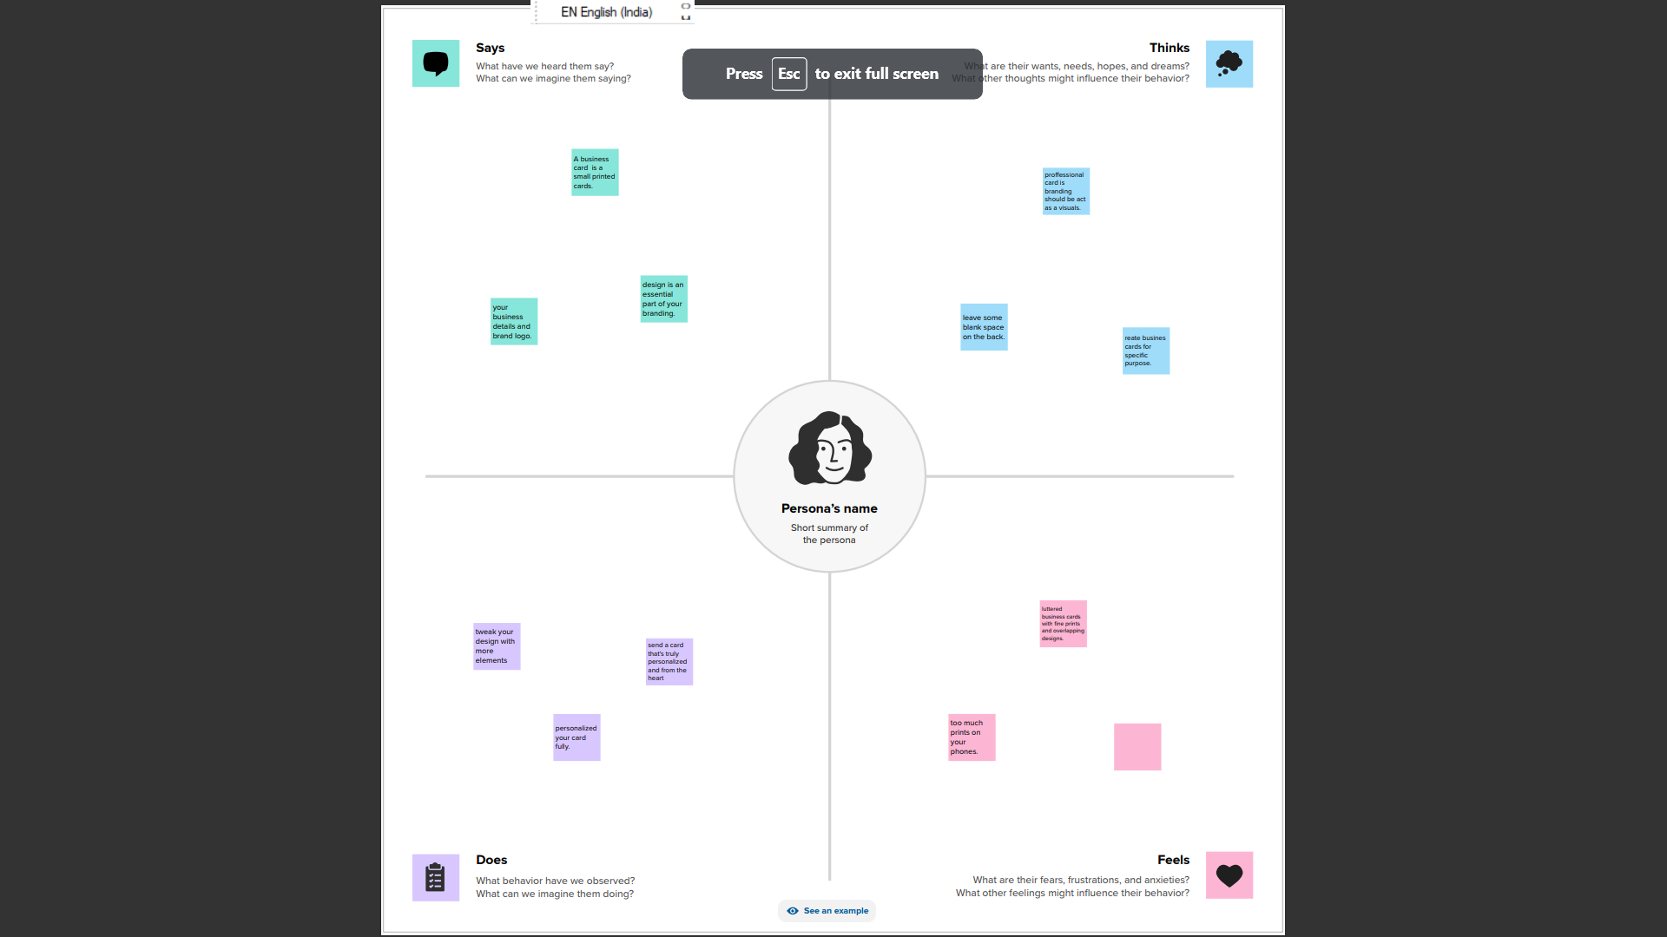

* 1. Ideation & Brainstorming map

Paste the ideation & brainstorming map sreenshot

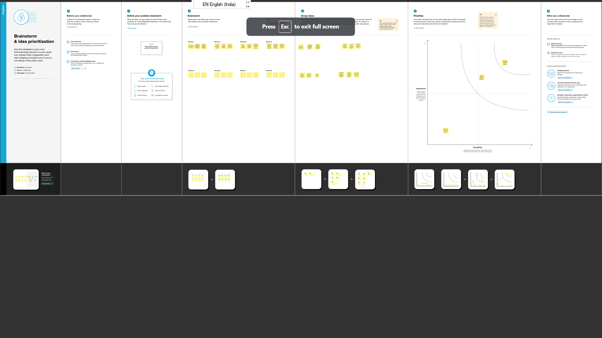

1. RESULT

Final flindings(output)of the project along with screenshot

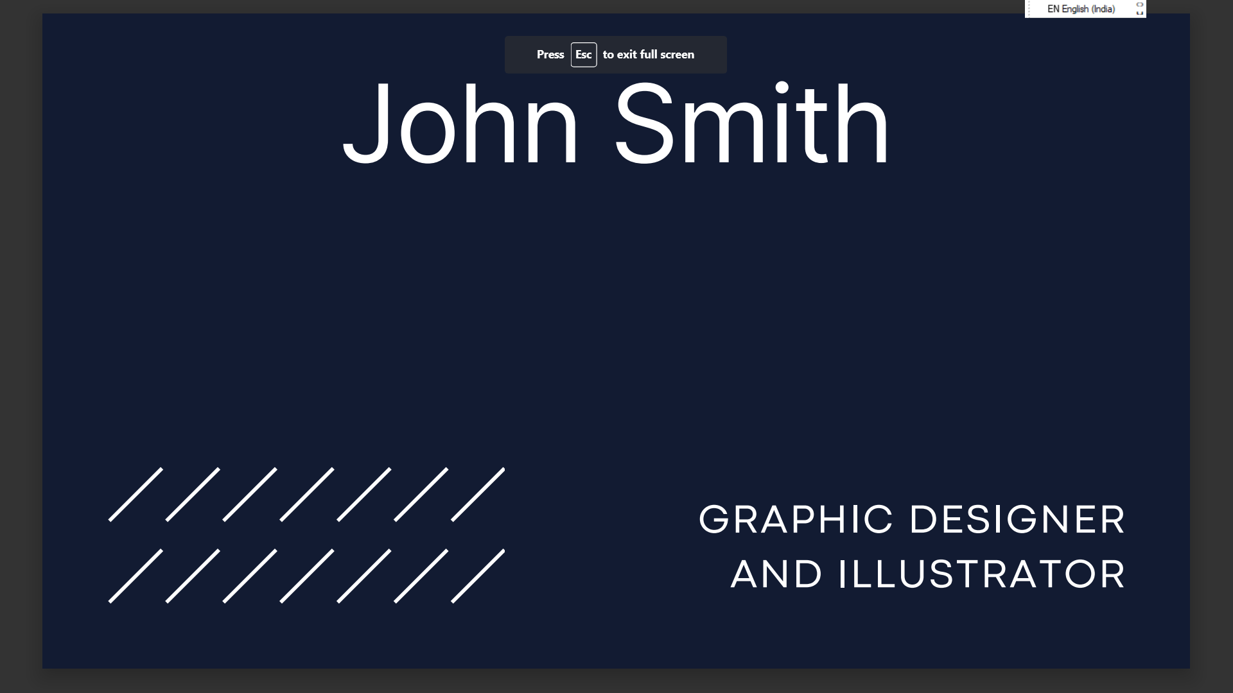

1. ADVANTAGES & DISADVANTAGES

1.Gives A Great First Impression .

2.Gives A visual Aid To remember your business.

3.Laminating cards might help.

4.many people don’t want to receive business cards.

5 APPLICATIONS